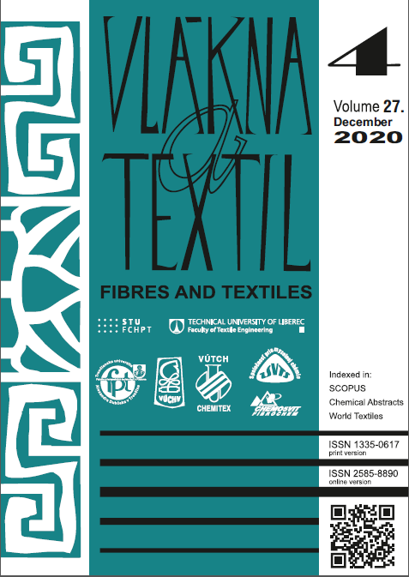

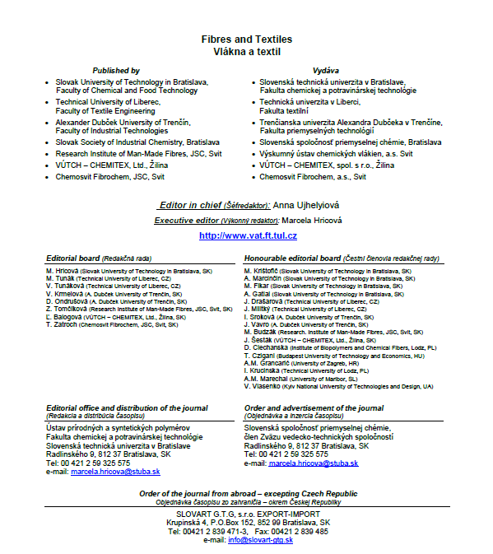

96 Marcela Skodova, Viera Glombikova, Petra Komarkova and Antonin Havelka
PERFORMANCE OF TEXTILE MATERIALS FOR THE NEEDS OF CHILDREN WITH SKIN PROBLEMS
102 Mykola Skyba, Oleh Polishchuk, Vitalii Neimak, Taras Romanets, Andrii Polishchuk, Svitlana Lisevych
and Maksym Luchynskyi
ANALYSIS OF FORCE INTERACTION BETWEEN PUNCHEON’S WORKING TOOL AND METAL
FITTINGS AT THE STAGE OF DEFORMATION OF PUNCHEON’S LAST CONIC PART
106 A. Slavinska, О. Syrotenko, V. Mytsa and O. Dombrovska
DEVELOPMENT OF THE PRODUCTION MODEL OF SCALING UNIFORMITY OF THE ASSORTMENT
COMPLEX CLOTHING FAMILY LOOK
118 Gökçe Tabaklı, Zümrüt Bahadır Ünal and Eda Acar
TEMPORAL EVALUATION OF CUSTOMIZED CLOTHING PATTERNS AND PATTERN DESIGNS
122 Zita Tomčíková, Štefan Krivoš and Jana Ileninová
STUDY ON VARIOUS DISPERSANTS IN PP MASTERBATCHES AND FIBRES MODIFIED
BY PROTECTIVE PHOTOLUMINESCENT PIGMENT
128 Olena Yakymchuk, Mariia Artemenko, Olena Chepelyuk, Anna Polietaieva, Nadiia Myrhorodska,
Larisa Shpak, Sergii Gakhovych, Inna Yakovets, Oleksandr Luhovskyi and Mykola Blyzniuk
THE DRAGON IMAGE AS AN INSPIRATION IN THE DESIGN OF COSTUMES WITH CONSIDERING
TECHNICAL ASPECTS
138 Alexander Zasornov, Iryna Zasornova and Inna Marynchenko
EXPERIMENTAL INVESTIGATION OF MULTILAYER THERMAL INSULATION MATERIAL
PERFORMANCE WITH USING OF DISCRETE HEAT TRANSFER MODEL
145 B.S. Zavertannyi, О.О. Akymov, О.P. Manoilenko, M.A. Zenkin, Y.A. Kovalev and S.A. Pleshko
RESEARCH OF THE INFLUENCE OF THE TREATMENT PROCESS OF THREE-CONE PACKING
ON CRITICAL SPEEDS OF BOBBIN HOLDER OF THE WINDING MACHINE
150 Tetyana Zhylenko, Oksana Zakharkevich, Julia Koshevko and Svitlana Kuleshova
PARAMETRIZATION OF THE HIERARCHICAL STRUCTURE OF THE TREE OF PILLS EMERGENCE
DURING PILLING FORMATION ON TEXTILE MATERIALS

